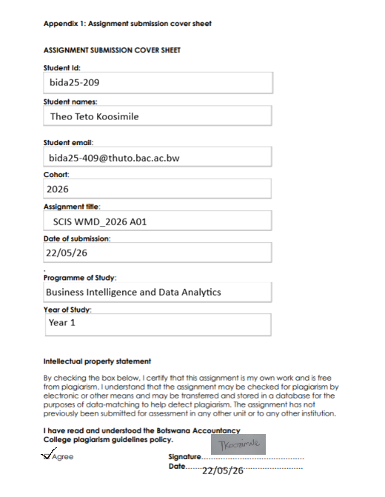

Sony Group Corporation-Website Design Process
This document is to provide a detailed description of what the webpage would entail, along with its purpose and structure.
Website specification
The objective of the Sony website is to give insight into the different technological products and services that the Sony Group Corporation has to offer (informative). This is to further provide accessibility and to well inform customers of the hardware in stock as well as the various prices for each respective product. It will as well emphasize on showcasing the organizations brand and to highlight different categories like electronics(devices), entertainment(gaming) and technological innovation.
This website is mainly targeted towards those mainly between 18-45 years old including university students, working professionals as well as tech enthusiasts. The products appeal to both male and female customers worldwide in urban and semi urban areas where technological use is high.
Sony also focuses on lower middle class up to high income consumers with a variety of gadgets that range from premium electronics to a more budget based systems with quality being assured across every product.
Users who value quality and performance are also the intended market for our devices that are entertainment oriented and digital.
The webpage is to also be offered to over many individuals with different uses and technical abilities of the devices and systems. These include:
- General/Everyday users that intend on browsing through the website
- Tech enthusiasts that are aware of product specifications and understand flagship features like high resolution, noise cancelling and interactive systems
- Gamers that are interested in console performance, accessories and online servers
- Creative users that are well knowledgeable in photography, production and site capturing
- Developers that understand advanced specifications, compatibility requirements associated with the devices, firmware updates and system integration.
Information Design and Taxonomy
This website will follow a simple structure that can easily be broken down into well detailed sections that can be navigated by everyone effortlessly. The home page will contain an overview of the websites features and such can possibly be achieved through a linear Structure. The design below will illustrate the websites layout.
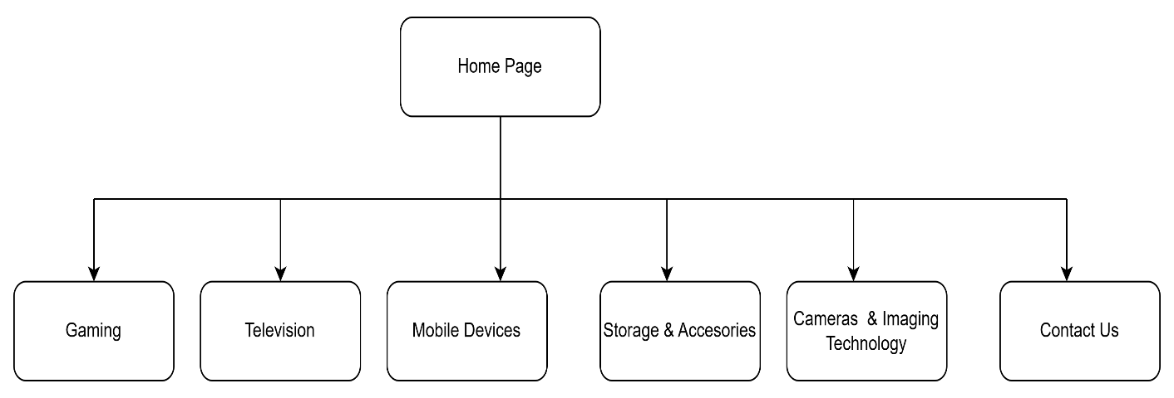

Graphic Design and Page Template Creation
The Sony products website consists of a high-fidelity wireframe that was designed using the moqups website( https://moqups.com/). Below are the set images of the wireframes.
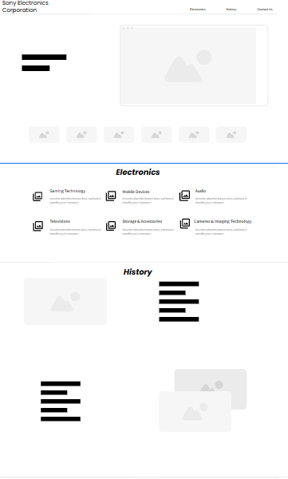

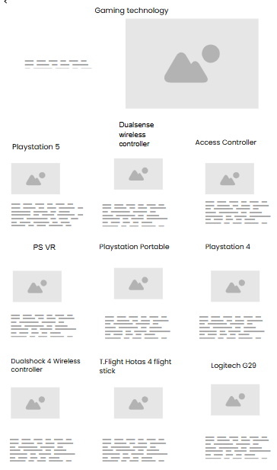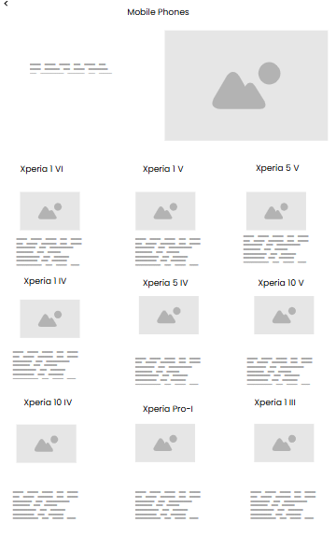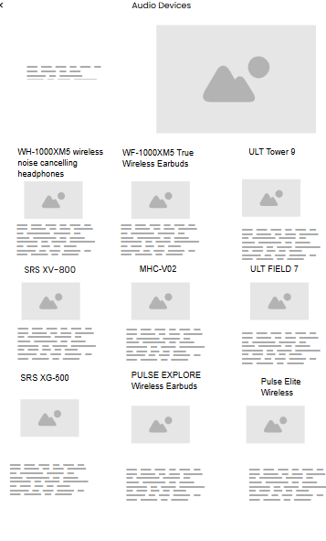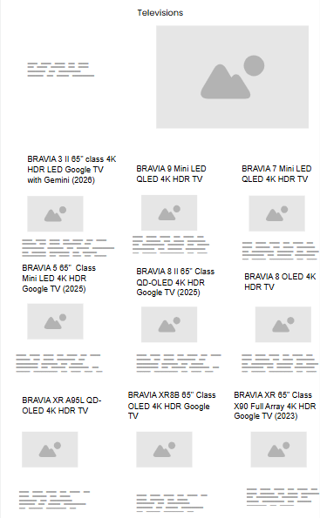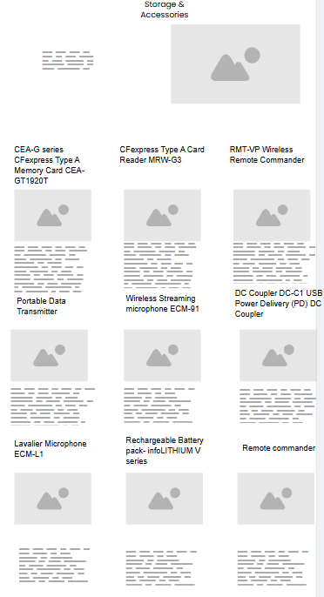
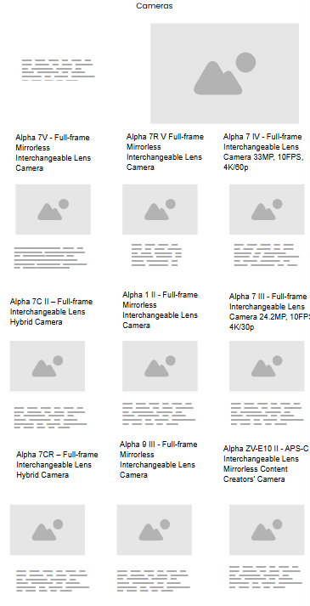
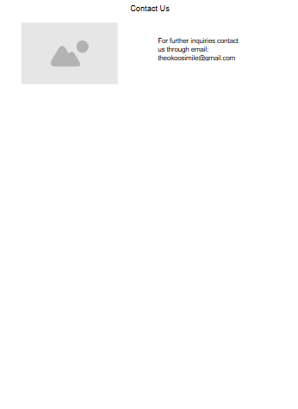
Construction and Development
The material was semantically organized using HTML5, which made sure that every section such as headers, navigation menus, product grids, and footer was appropriately defined for search optimization and accessibility. Semantic elements like and were used to assist establish a clear hierarchy that reflects the logical structure of the website and improves readability for both users and browsers.
The website has a sleek, dark, Sony-inspired appearance with contrasting white and blue highlights thanks to the use of CSS3 to style and unify its visual identity. Whether viewed on a desktop or mobile device, the design maintains clarity and balance thanks to grid layouts, flexbox, and responsive media queries. While uniform spacing and typography guarantee a clean, businesslike appearance across all pages, transitions and hover effects were included to enhance interaction and user engagement.
JavaScript was incorporated to improve functionality and engagement, including responsive elements that respond to user input, dynamic navigation behavior, and image carousels. These technologies work together to produce a seamless and user-friendly browsing experience. The website was subjected to cross-browser testing, responsiveness verification on various screen sizes, and validation checks for HTML and CSS compliance as part of quality assurance. In order to guarantee usability for all users, accessibility requirements were also examined. The outcome is a strong, superior web platform that satisfies contemporary development and design standards.

